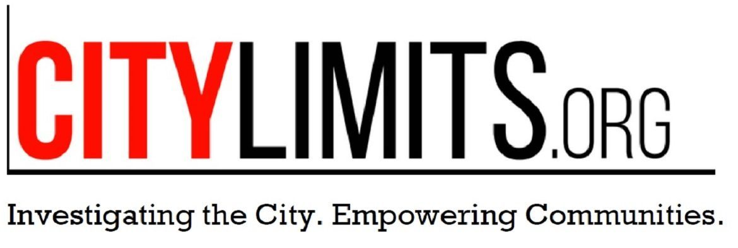
- This event has passed.

Italian Playwrights Project: SOMETHING ABOUT LEHMAN with Stefano Massini

December 5, 2016 @ 6:30 pm - 9:00 pm

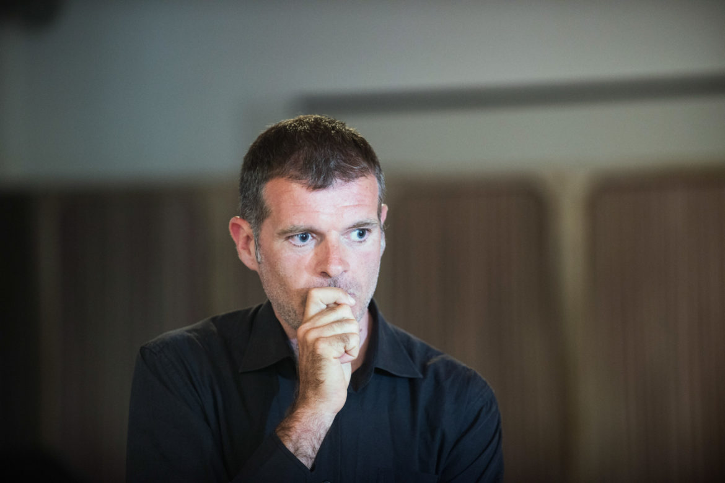

Italian Playwrights Project presents the event SOMETHING ABOUT LEHMAN, a conversation with Italian playwright Stefano Massini about his work as well as the role of the Piccolo Teatro di Milano and contemporary theatre in Europe. At the artist talk, moderated by The Martin E. Segal Theatre Center Executive Director and Director of Programs Dr. Frank Hentschker, Massini will be joined by Umanism founder and director Valeria Orani and Giorgio Van Straten, Director of the Italian Cultural Institute of New York. The event will also feature a reading of an excerpt from THE LEHMAN TRILOGY, translated by Allison Eikerenkoetter, directed by Marco Calvani, and performed by actor Robert Funaro.
SOMETHING ABOUT LEHMAN by Italian playwright Stefano Massini tells the story of the historic rise and fall of Lehman Brothers investment house. The fiction book is based on Massini’s theatre plays THE LEHMAN TRILOGY, a five-hour saga that traces the legacy of the infamous banking family back three generations, beginning with their humble arrival to America in the mid-1800s and ending with their empire’s eventual demise in 2008.
The play premiered at the Piccolo Teatro in Milan in 2015 abd was the last work of legendary Italian theatre director Luca Ronconi. It has since been produced widely in Europe. The Oscar Award winning director Sam Mendes will be staging THE LEHMAN TRILOGY for the National Theatre in London.
Italian Playwrights Project created by Valeria Orani (Umanism NY, umanism.com) and Frank Hentschker (Martin Segal Theatre Center) in collaboration with Italian Cultural Institute in New York, Giorgio Van Straten, Director (iicnewyork.esteri.it)

+ GOOGLE CALENDAR+ ICAL EXPORT

Details
Date:
December 5, 2016
Time:
6:30 pm - 9:00 pm
Event Categories:
Reading, Theater
Website:
http://www.gc.cuny.edu/All-GC-Events/Calendar/Detail?id=37368

Venue
CUNY The Graduate Center
365 5th Ave, New York, NY 10016

