Italian Playwrights Project Stefano Massini's SOMETHING ABOUT THE LEHMANS at Segal Center
by BWW News Desk

Nov. 30, 2016 Tweet Share

Not able to attend? Watch our livestream at www.theSegalCenter.org/home
Event + livestream start at 6:30pm on December 5
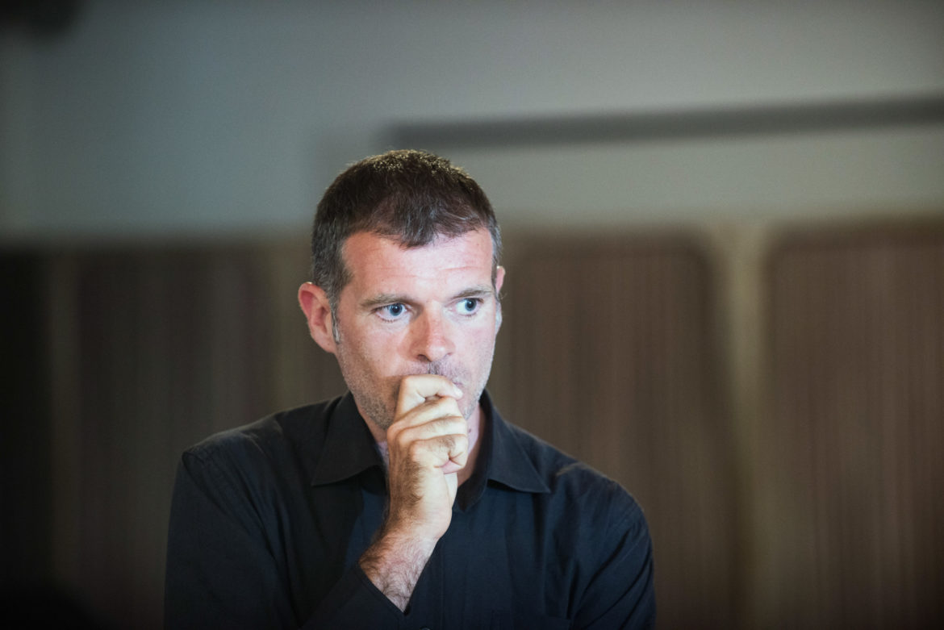
Something About The Lehmans by Italian playwright Stefano Massini tells the story of the historic rise and fall of the Lehman Brothers investment house. This fictional book is based on Massini's theatre plays The Lehman Trilogy, a five-hour saga that traces the legacy of the infamous banking family back three generations, beginning with their humble arrival to America in the mid?1800s and ending with their empire's eventual demise in 2008.
The play premiered at the Piccolo Teatro di Milano-Teatro d'Europa in 2015 and was the last work of legendary Italian theatre director Luca Ronconi.

It has since been produced widely in Europe. Oscar Award-winning director Sam Mendes will be staging The Lehman Trilogy.

Join us for a conversation with Stefano Massini about his work, the history of the Piccolo Teatro di Milano, and Contemporary Theatre in Europe.
The event will also feature a reading of an excerpt from Something about the Lehmans, translated by Allison Eikerenkoetter, directed by Marco Calvani, and performed by Robert Funaro.
Italian Playwrights Project created by Valeria Orani (369gradi Italy/ Umanism NY, www.umanism.com) and Frank Hentschker (Martin E. Segal Theatre Center) in collaboration with Giorgio Van Straten (Director, Italian Cultural Institute in New York (www.iicnewyork.esteri.it).
This event is made possible by the generous support of Joseph LoCicero/ The Segal Company

